How is data read?
To satisfy a read, Cassandra must combine results from the active memtable and potentially multiple SSTables.
Cassandra processes data at several stages on the read path to discover where the data is stored, starting with the data in the memtable and finishing with SSTables:
- Check the memtable
- Check row cache, if enabled
- Checks Bloom filter
- Checks partition key cache, if enabled
- Goes directly to the compression offset map if a partition key is found in the partition key cache, or checks the partition summary if not
If the partition summary is checked, then the partition index is accessed
- Locates the data on disk using the compression offset map
- Fetches the data from the SSTable on disk
Read request flow
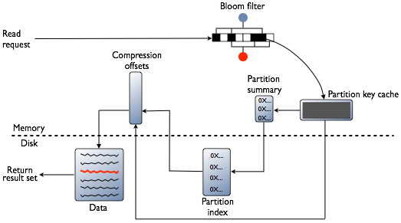
Row cache and Key cache request flow
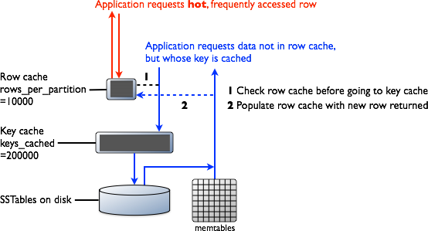

Memtable
If the memtable has the desired partition data, then the data is read and then merged with the data from the SSTables. The SSTable data is accessed as shown in the following steps.

Row Cache
Typical of any database, reads are fastest when the most in-demand data fits into memory. The operating system page cache is best at improving performance, although the row cache can provide some improvement for very read-intensive operations, where read operations are 95% of the load. Row cache is contra-indicated for write-intensive operations. The row cache, if enabled, stores a subset of the partition data stored on disk in the SSTables in memory. In Cassandra 2.2 and later, it is stored in fully off-heap memory using a new implementation that relieves garbage collection pressure in the JVM. The subset stored in the row cache use a configurable amount of memory for a specified period of time. The row cache uses LRU (least-recently-used) eviction to reclaim memory when the cache has filled up.
The row cache size is configurable, as is the number of rows to store. Configuring the number of rows to be stored is a useful feature, making a "Last 10 Items" query very fast to read. If row cache is enabled, desired partition data is read from the row cache, potentially saving two seeks to disk for the data. The rows stored in row cache are frequently accessed rows that are merged and saved to the row cache from the SSTables as they are accessed. After storage, the data is available to later queries. The row cache is not write-through. If a write comes in for the row, the cache for that row is invalidated and is not cached again until the row is read. Similarly, if a partition is updated, the entire partition is evicted from the cache. When the desired partition data is not found in the row cache, then the Bloom filter is checked.

Bloom Filter
First, Cassandra checks the Bloom filter to discover which SSTables are likely to have the request partition data. The Bloom filter is stored in off-heap memory. Each SSTable has a Bloom filter associated with it. A Bloom filter can establish that a SSTable does not contain certain partition data. A Bloom filter can also find the likelihood that partition data is stored in a SSTable. It speeds up the process of partition key lookup by narrowing the pool of keys. However, because the Bloom filter is a probabilistic function, it can result in false positives. Not all SSTables identified by the Bloom filter will have data. If the Bloom filter does not rule out an SSTable, Cassandra checks the partition key cache
The Bloom filter grows to approximately 1-2 GB per billion partitions. In the extreme case, you can have one partition per row, so you can easily have billions of these entries on a single machine. The Bloom filter is tunable if you want to trade memory for performance.

Partition Key Cache
The partition key cache, if enabled, stores a cache of the partition index in off-heap memory. The key cache uses a small, configurable amount of memory, and each "hit" saves one seek during the read operation. If a partition key is found in the key cache can go directly to the compression offset map to find the compressed block on disk that has the data. The partition key cache functions better once warmed, and can greatly improve over the performance of cold-start reads, where the key cache doesn't yet have or has purged the keys stored in the key cache. It is possible to limit the number of partition keys saved in the key cache, if memory is very limited on a node. If a partition key is not found in the key cache, then the partition summary is searched.
The partition key cache size is configurable, as are the number of partition keys to store in the key cache.

Partition Summary
The partition summary is an off-heap in-memory structure that stores a sampling of the partition index. A partition index contains all partition keys, whereas a partition summary samples every X keys, and maps the location of every Xth key's location in the index file. For example, if the partition summary is set to sample every 20 keys, it will store the location of the first key as the beginning of the SSTable file, the 20th key and its location in the file, and so on. While not as exact as knowing the location of the partition key, the partition summary can shorten the scan to find the partition data location. After finding the range of possible partition key values, the partition index is searched.
By configuring the sample frequency, you can trade memory for performance, as the more granularity the partition summary has, the more memory it will use. The sample frequency is changed using the index interval property in the table definition. A fixed amount of memory is configurable using the index_summary_capacity_in_mb property, and defaults to 5% of the heap size.

Partition Index
The partition index resides on disk and stores an index of all partition keys mapped to their offset. If the partition summary has been checked for a range of partition keys, now the search passes to the partition index to seek the location of the desired partition key. A single seek and sequential read of the columns over the passed-in range is performed. Using the information found, the partition index now goes to the compression offset map to find the compressed block on disk that has the data. If the partition index must be searched, two seeks to disk will be required to find the desired data.

Compression offset map
The compression offset map stores pointers to the exact location on disk that the desired partition data will be found. It is stored in off-heap memory and is accessed by either the partition key cache or the partition index. The desired compressed partition data is fetched from the correct SSTable(s) once the compression offset map identifies the disk location. The query receives the result set.
Note: Within a partition, all rows are not equally expensive to query. The very beginning of the partition (the first rows, clustered by your key definition) is slightly less expensive to query because there is no need to consult the partition-level index.
The compression offset map grows to 1-3 GB per terabyte compressed. The more you compress data, the greater number of compressed blocks you have and the larger the compression offset table. Compression is enabled by default even though going through the compression offset map consumes CPU resources. Having compression enabled makes the page cache more effective, and typically, almost always pays off.

How is data deleted?
Cassandra's processes for deleting data are designed to improve performance, and to work with Cassandra's built-in properties for data distribution and fault-tolerance.
Cassandra treats a delete as an insert or upsert. The data being added to the partition in the DELETE command is a deletion marker called a tombstone. The tombstones go through Cassandra's write path, and are written to SSTables on one or more nodes. The key difference feature of a tombstone: it has a built-in expiration date/time. At the end of its expiration period (for details see below) the tombstone is deleted as part of Cassandra's normal compaction process.
You can also mark a Cassandra record (row or column) with a time-to-live value. After this amount of time has ended, Cassandra marks the record with a tombstone, and handles it like other tombstoned records.

Deletion in a distributed system
In a multi-node cluster, Cassandra can store replicas of the same data on two or more nodes. This helps prevent data loss, but it complicates the delete process. If a node receives a delete for data it stores locally, the node tombstones the specified record and tries to pass the tombstone to other nodes containing replicas of that record. But if one replica node is unresponsive at that time, it does not receive the tombstone immediately, so it still contains the pre-delete version of the record. If the tombstoned record has already been deleted from the rest of the cluster befor that node recovers, Cassandra treats the record on the recovered node as new data, and propagates it to the rest of the cluster. This kind of deleted but persistent record is called a zombie.
To prevent the reappearance of zombies, the database gives each tombstone a grace period. The purpose of the grace period is to give unresponsive nodes time to recover and process tombstones normally. When multiple replica answers are part of a read request, and those responses differ, then whichever values are most recent take precedence. For example, if a node has a tombstone but another node has a more recent change, then the final result includes the more recent change.
If a node has a tombstone and another node has only an older value for the record, then the final record will have the tombstone. If a client writes a new update to the tombstone during the grace period, the database overwrites the tombstone.
When an unresponsive node recovers, Cassandra uses hinted handoff to replay the database mutations the node missed while it was down. Cassandra does not replay a mutation for a tombstoned record during its grace period. But if the node does not recover until after the grace period ends, Cassandra may miss the deletion.
After the tombstone's grace period ends, Cassandra deletes the tombstone during compaction.
The grace period for a tombstone is set by the property gc_grace_seconds. Its default value is 864000 seconds (ten days). Each table can have its own value for this property.

More about Cassandra deletes
Details:
- The expiration date/time for a tombstone is the date/time of its creation plus the value of the table property gc_grace_seconds.
- Cassandra also supports Batch data insertion and updates. This procedure also introduces the danger of replaying a record insertion after that record has been removed from the rest of the cluster. Cassandra does not replay a batched mutation for a tombstoned record that is still within its grace period.
- On a single-node cluster, you can set gc_grace_seconds to 0 (zero).
- To completely prevent the reappearance of zombie records, run nodetool repair on a node after it recovers, and on each table every gc_grace_seconds.
- If all records in a table are given a TTL at creation, and all are allowed to expire and not deleted manually, it is not necessary to run nodetool repair for that table on a regular basis.
- If you use the SizeTieredCompactionStrategy or DateTieredCompactionStrategy, you can delete expired tombstones immediately by manually starting the compaction process.
CAUTION: If you force compaction, Cassandra may create one very large SSTable from all the data. Cassandra will not trigger another compaction for a long time. The data in the SSTable created during the forced compaction can grow very stale during this long period of non-compaction.
- Cassandra allows you to set a default_time_to_live property for an entire table. Columns and rows marked with regular TTLs are processed as described above; but when a record exceeds the table-level TTL, Cassandra deletes it immediately, without tombstoning or compaction.
- Cassandra supports immediate deletion through the DROP KEYSPACE and DROP TABLE statements.

How are indexes stored and updated?
Secondary indexes are used to filter a table for data stored in non-primary key columns. For example, a table storing cyclist names and ages using the last name of the cyclist as the primary key might have a secondary index on the age to allow queries by age. Querying to match a non-primary key column is an anti-pattern, as querying should always result in a continuous slice of data retrieved from the table.
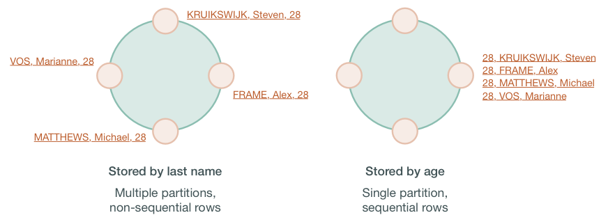
If the table rows are stored based on last names, the table may be spread across several partitions stored on different nodes. Queries based on a particular range of last names, such as all cyclists with the last name Matthews will retrieve sequential rows from the table, but a query based on the age, such as all cyclists who are 28, will require all nodes to be queried for a value. Non-primary keys play no role in ordering the data in storage, thus querying for a particular value of a non-primary key column results in scanning all partitions. Scanning all partitions generally results in a prohibitive read latency, and is not allowed.
Secondary indexes can be built for a column in a table. These indexes are stored locally on each node in a hidden table and built in a background process. If a secondary index is used in a query that is not restricted to a particular partition key, the query will have prohibitive read latency because all nodes will be queried. A query with these parameters is only allowed if the query option ALLOW FILTERING is used. This option is not appropriate for production environments. If a query includes both a partition key condition and a secondary index column condition, the query will be successful because the query can be directed to a single node partition.
This technique, however, does not guarantee trouble-free indexing, so know when and when not to use an index. In the example shown above, an index on the age could be used, but a better solution is to create a materialized view or additional table that is ordered by age.
As with relational databases, keeping indexes up to date uses processing time and resources, so unnecessary indexes should be avoided. When a column is updated, the index is updated as well. If the old column value still exists in the memtable, which typically occurs when updating a small set of rows repeatedly, Cassandra removes the corresponding obsolete index entry; otherwise, the old entry remains to be purged by compaction. If a read sees a stale index entry before compaction purges it, the reader thread invalidates it.

About commands
nodetool utility is a command line interface for managing a cluster.
- If a username and password for RMI authentication are set explicitly in the cassandra-env.sh file for the host, then you must specify credentials.
- The repair and rebuild commands can affect multiple nodes in the cluster.
- Most nodetool commands operate on a single node in the cluster if -h is not used to identify one or more other nodes. If the node from which you issue the command is the intended target, you do not need the -h option to identify the target; otherwise, for remote invocation, identify the target node, or nodes, using -h.
nodetool help
nodetool help upgradesstables (help for a specific command)

nodetool describecluster
Cluster Information:
Name: Test Cluster
Snitch: org.apache.cassandra.locator.DynamicEndpointSnitch
Partitioner: org.apache.cassandra.dht.Murmur3Partitioner
Schema versions:
65e78f0e-e81e-30d8-a631-a65dff93bf82: [127.0.0.1]
If a schema disagreement occurs, the last line of the output includes information about unreachable nodes.
nodetool describecluster
Cluster Information:
Name: Production Cluster
Snitch: org.apache.cassandra.locator.DynamicEndpointSnitch
Partitioner: org.apache.cassandra.dht.Murmur3Partitioner
Schema versions:
UNREACHABLE: 1176b7ac-8993-395d-85fd-41b89ef49fbb: [10.202.205.203]

nodetool describering
Provides the partition ranges of a keyspace.
If a schema disagreement occurs, the last line of the output includes information about unreachable nodes.
nodetool describecluster
Cluster Information:
Name: Production Cluster
Snitch: org.apache.cassandra.locator.DynamicEndpointSnitch
Partitioner: org.apache.cassandra.dht.Murmur3Partitioner
Schema versions:
UNREACHABLE: 1176b7ac-8993-395d-85fd-41b89ef49fbb: [10.202.205.203]

nodetool describering demo_keyspace
Schema Version:1b04bd14-0324-3fc8-8bcb-9256d1e15f82
TokenRange:
TokenRange(start_token:3074457345618258602, end_token:-9223372036854775808,
endpoints:[127.0.0.1, 127.0.0.2, 127.0.0.3],
rpc_endpoints:[127.0.0.1, 127.0.0.2, 127.0.0.3],
endpoint_details:[EndpointDetails(host:127.0.0.1, datacenter:datacenter1, rack:rack1),
EndpointDetails(host:127.0.0.2, datacenter:datacenter1, rack:rack1),
EndpointDetails(host:127.0.0.3, datacenter:datacenter1, rack:rack1)])
TokenRange(start_token:-3074457345618258603, end_token:3074457345618258602,
endpoints:[127.0.0.3, 127.0.0.1, 127.0.0.2],
rpc_endpoints:[127.0.0.3, 127.0.0.1, 127.0.0.2],
endpoint_details:[EndpointDetails(host:127.0.0.3,
datacenter:datacenter1, rack:rack1),
EndpointDetails(host:127.0.0.1, datacenter:datacenter1, rack:rack1),
EndpointDetails(host:127.0.0.2, datacenter:datacenter1, rack:rack1)])
TokenRange(start_token:-9223372036854775808, end_token:-3074457345618258603,
endpoints:[127.0.0.2, 127.0.0.3, 127.0.0.1],
rpc_endpoints:[127.0.0.2, 127.0.0.3, 127.0.0.1],
endpoint_details:[EndpointDetails(host:127.0.0.2, datacenter:datacenter1, rack:rack1),
EndpointDetails(host:127.0.0.3, datacenter:datacenter1, rack:rack1),
EndpointDetails(host:127.0.0.1, datacenter:datacenter1, rack:rack1)])

nodetool info
Provides node information, such as load and uptime.

Description
Provides node information including the token and on disk storage (load) information, times started (generation), uptime in seconds, and heap memory usage.

nodetool netstats
Provides network information about the host.

Description
The default host is the connected host if the user does not include a host name or IP address in the command. The output includes the following information:
- JVM settings
- Mode
The operational mode of the node: JOINING, LEAVING, NORMAL, DECOMMISSIONED, CLIENT
- Read repair statistics
- Attempted
The number of successfully completed read repair operations
- Mismatch (blocking)
The number of read repair operations since server restart that blocked a query.
- Mismatch (background)
The number of read repair operations since server restart performed in the background.
- Pool name
Information about client read and write requests by thread pool.
- Active, pending, and completed number of commands and responses

Example
Get the network information for a node 10.171.147.128:
nodetool -h 10.171.147.128 netstats
The output is:
Mode: NORMAL
Not sending any streams.
Read Repair Statistics:
Attempted: 0
Mismatch (Blocking): 0
Mismatch (Background): 0
Pool Name Active Pending Completed
Commands n/a 0 1156
Responses n/a 0 2750

nodetool ring
Provides node status and information about the ring.

Description
Displays node status and information about the ring as determined by the node being queried. This information can give you an idea of the load balance and if any nodes are down. If your cluster is not properly configured, different nodes may show a different ring. Check that the node appears the same way in the ring.If you use virtual nodes (vnodes), use nodetool status for succinct output.
- Address
The node's URL.
- DC (datacenter)
The datacenter containing the node.
- Rack
The rack or, in the case of Amazon EC2, the availability zone of the node.
- Status - Up or Down
Indicates whether the node is functioning or not.
- State - N (normal), L (leaving), J (joining), M (moving)
The state of the node in relation to the cluster.
- Load - updates every 90 seconds
The amount of file system data under the cassandra data directory after excluding all content in the snapshots subdirectories. Because all SSTable data files are included, any data that is not cleaned up, such as TTL-expired cell or tombstoned data) is counted.
- Token
The end of the token range up to and including the value listed. For an explanation of token ranges, see Data Distribution in the Ring .
- Owns
The percentage of the data owned by the node per datacenter times the replication factor. For example, a node can own 33% of the ring, but show100% if the replication factor is 3.
- Host ID
The network ID of the node.
On this page
- Synopsis
- Description

nodetool statusgossip
Provides the status of gossip.

nodetool tpstats
Provides usage statistics of thread pools.

Description
Cassandra is based on a Staged Event Driven Architecture (SEDA). Cassandra separates different tasks into stages connected by a messaging service. Each stage has a queue and a thread pool. Although some stages skip the messaging service and queue tasks immediately on a different stage when it exists on the same node. Cassandra can back up a queue if the next stage is too busy and lead to a performance bottlenecks.
The nodetool tpstats command reports on each stage of Cassandra operations by thread pool:
- The number of Active threads
- The number of Pending requests waiting to be executed by this thread pool
- The number of tasks Completed by this thread pool
- The number of requests that are currently Blocked because the thread pool for the next step in the service is full
- The total number of All-Time Blocked requests, which are all requests blocked in this thread pool up to now.
Reports are updated when SSTables change through compaction or flushing.
Run nodetool tpstats on a local node to get statistics for the thread pool used by the Cassandra instance running on that node.
Run nodetool tpstats with the appropriate options to check the thread pool statistics for a remote node. For setup instructions, see Secure JMX Authentication.
nodetool tpstats pool names and tasks

